DATABASE TABLES AND FOREIGN KEY.

1. TABLE:ZHA_BANK

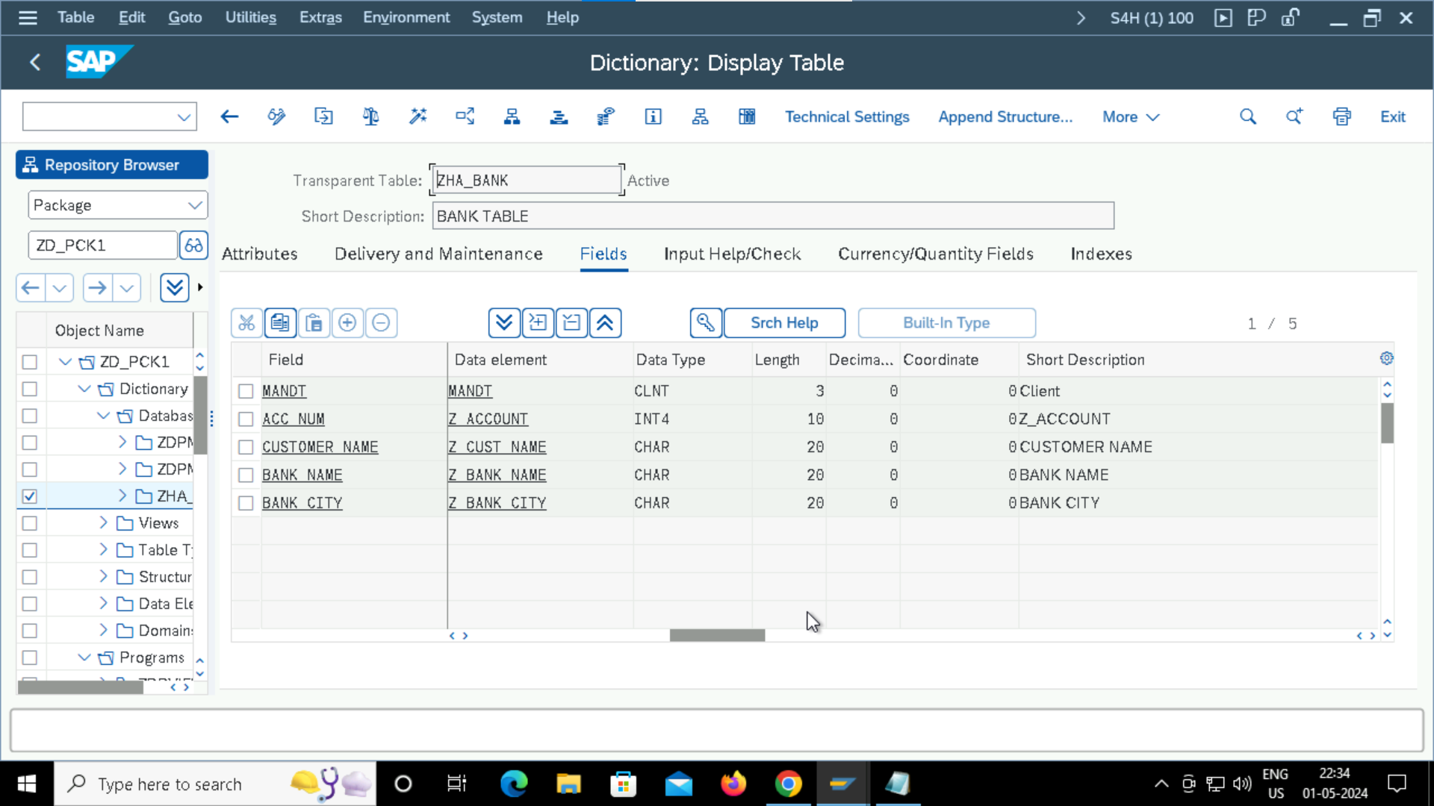

1. CREATED ANOTHER TABLE

1. CREATING FOREIGN KEY.

